ФОРМИРОВАНИЕ ЧИТАТЕЛЬСКИХ КОМПЕТЕНЦИЙ
В 4 КЛАССЕ НА ОСНОВЕ ДОМАШНЕГО ЧТЕНИЯ НА АНГЛИЙСКОМ ЯЗЫКЕ

Аммаева Марина Абдулкадыровна
учитель английского языка, МБОУ СОШ №4 г. Десногорска

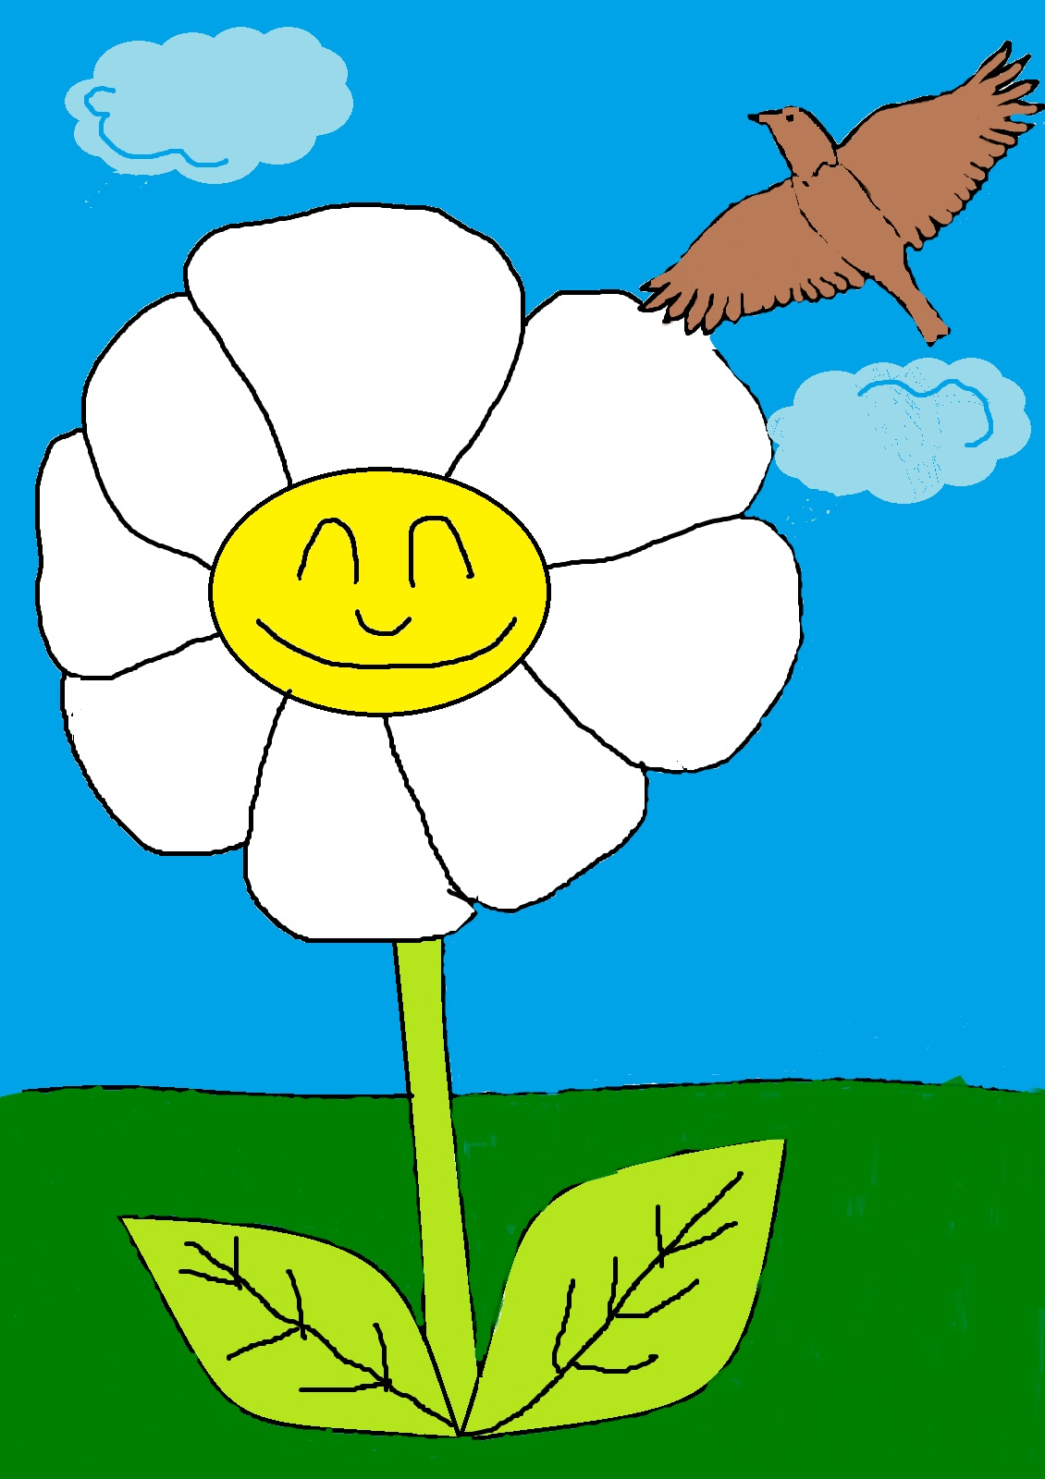

The Daisy
In the country close by the roadside, there stood a cottage. In front there was a little garden full of the fence there grew, in the grass , a Daisy.
The Daisy was quite contented. She looked up to the blue sky and listened to a lark singing in the air.
How happy the little Daisy was one can ever tell!
The lark kissed her sang to her, and then flew up again into the warm blue sky. He looked at the other flowers in the garden, but he could see that they were angry.
Once a girl came into the garden with a sharp knife and cut off tulips.
How glad was the Daisy that she grew in the grass.
The next morning Daisy heard the voice of the Lark; but he sang mournfully. The Lark was into a cage.
The little Daisy wanted to help him; but how could she? And because she could not, she forgot how beautiful everything around her was. Then she could only think of the little poor bird.
Suddenly two little boys came out of the garden. One of them had a knife in his hand. They went up straight to the Daisy and began to cut deep all round the Daisy, leaving her in the centre.
When the boys came they saw that the Lark was dead. They put the bird ' s dead body into a pretty box and buried it. And the turf with the Daisy was thrown out into the dusty road. No one thought of the flower that had so much wished to comfort the poor little bird.
Whilst the Lark lived and sang, they forgot him and tears were shed over him.

1 группа умений
(Общее понимание и ориентация в тексте)
Before reading.
How much do you know about plants and animals ?
1. Do you like animals?
2. Have you got any pets?
3.Did you see any films about animals?
1. Основная мысль рассказа.
1. The Daisy is happy.
2. The Daisy wanted to comfort the Lark.
3. Children wanted to have the bird but forgot that they must take care of it

2. Найдите где описывается чувства ромашки к жаворонку, заточенному в клетку.
a) The Daisy was quite contented she looked up to the blue sky and listened to a Lark singing in the air.
b) The little Daisy wanted to help him; but how could she? And because she could not, she forgot how beautiful everything around her was. . Then she could only think of the little poor bird
c) So the Daisy was put into the Lark ' s cage . There were no water in the cage and soon the Lark and the Daisy dead.

3.В каком предложении заключается вывод:
1.The Daisy was quite contented.
2. How glad was the Daisy that she grew in the grass.
3. Whilst the Lark lived and sang, children forgot him and left him to die of thirst in his cage and when he dead his grave covered with flowers.
2 группа умений.
(Преобразование и интерпретация текста. Детальное чтение.)
1.В каком предложении говорится о беззаботной жизни ромашки.
a)They went up straight to the Daisy and began to cut deep all around the Daisy.
b)Daisy looked up to the blue sky and listened to the Lark singing in the air.
c) The next morning Daisy heard the voice of the Lark.
2.Какие эпитеты подходят для описания ромашки.
a) nice and contented
b) shy and kind
c) cruel and angry
3.Найдите абзац в котором говорится о нежном отношении жаворонка к ромашке.
a) The little Daisy wanted to help Lark; but how could she? And because she could not, she forgot how beautiful everything around her was.
b) The next morning Daisy heard the voice of the Lark;but he sang mournfully. The Lark was into a cage.
c) How happy the little Daisy was one can ever tell. The Lark kissed her sang to her;and then flew up again into the warm blue sky.
4. Оцените ситуацию с точки зрения сегодняшнего дня.
a) There are a lot of people who don’t think about other’s feelings.
b)People don’t take care of plants and animals.
c)People kill a lot of exotic animals because of money.
3 группа умений.
1. Почему история кажется такой грустной?
a) People mustn’t think only about themselves.
b) People must take care of animals and plants.
c) We mustn’t put wild animals into the cages.
2.В каких школьных предметах можно найти ответ на этот вопрос?
3.Какой абзац вам понравился больше всего?
1. I like the passage where the Lark sang songs to the Daisy, because I like stories about friendship.
2.I like the passage where the children put the Lark into the cage because this part teach us to love plants and animals.
3.I like all the story because I like stories about the nature.
4.Опишите поступок детей с вашей точки зрения.

